- Woodland Textured Embossing Folder - Stampin’ Up! Gives you a 6”x6” embossing folder which creates endless possibilities.
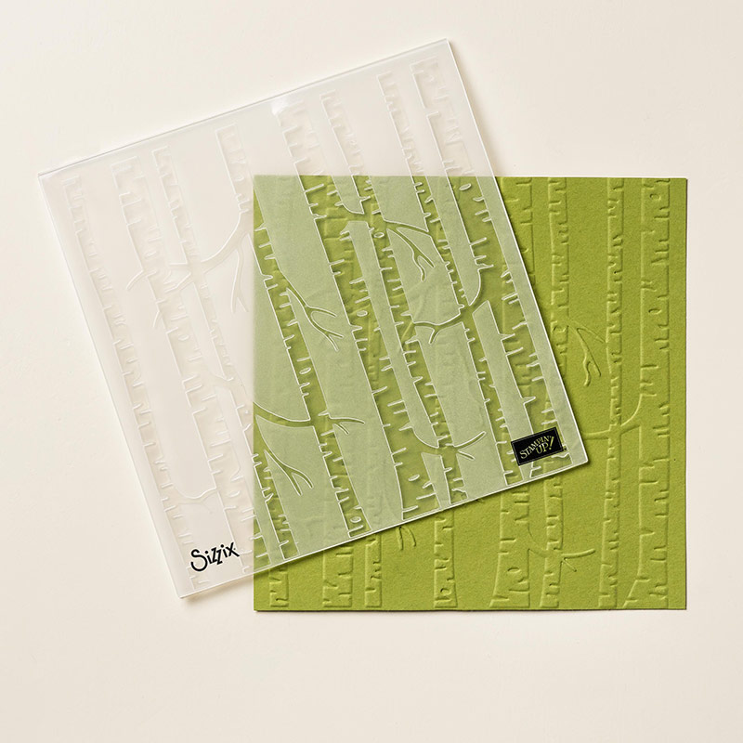
2. Festive Flower Punch (p.31)- more than just Christmas. Think of the occasions you want to add a flower that gives dimensions. You can bundle this with the Reason for the Season and be able to expand how you use this punch.
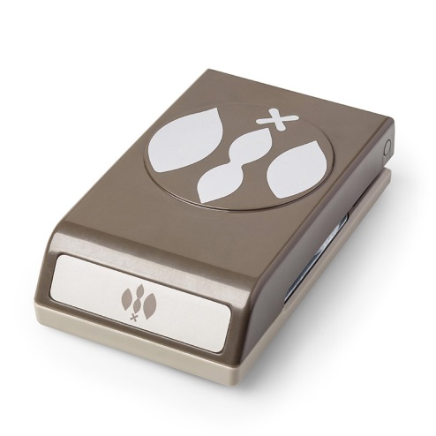
Watch the video to learn how easy it is to use. https://www.youtube.com/watch?feature=player_detailpage&v=KTRP5cvrgrg

- Reindeer Clips - adds interest to cards, tags, or special projects.

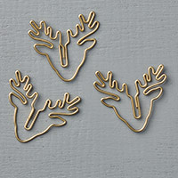

4. Among the Branches Stamp (p.39) You can bundle with the Woodlands Textured Embossing Folder.

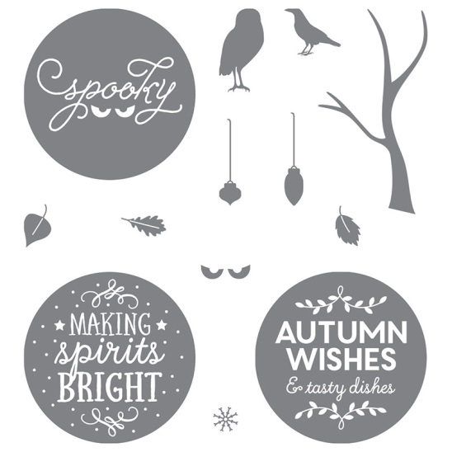

5. Embellished Ornaments (p.15) The Holidays need ornaments, but not just any ornaments. The intricate detail dies will show the fine details on your projects. This is another bundle and save 15% when you purchase together.

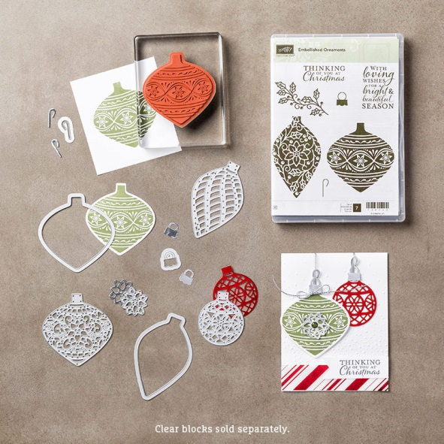

6. Snow Place with Framelits (p.33) - The Penguins and Snowmen will into your heart with their “costume changes.” Just they are just plain adorable! Save 15% by bundling the framelits with the stamp set.

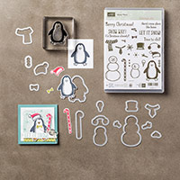

7. Flurry of Wishes (p.25)– Bundle with the new coordinating Snow Flurry and save 15%. The top left snowflake coordinates with the Flower Medallion Punch.
l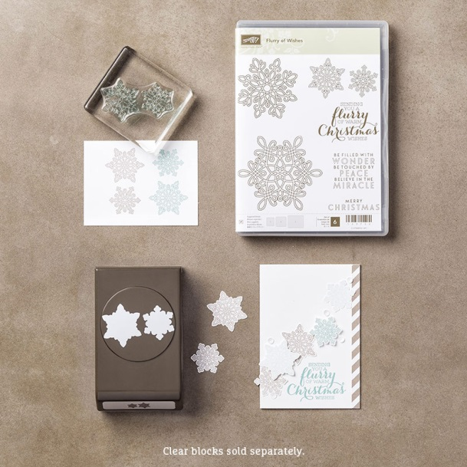

8. Howl-o-ween Treat (p.49) This stamp set may bewitch you, but the owl will charm you. The owl is not for just Halloween, but year round. Think outside the box and change the color of him. Maybe pink or blue for a baby card. This is another 15% save with bundling.
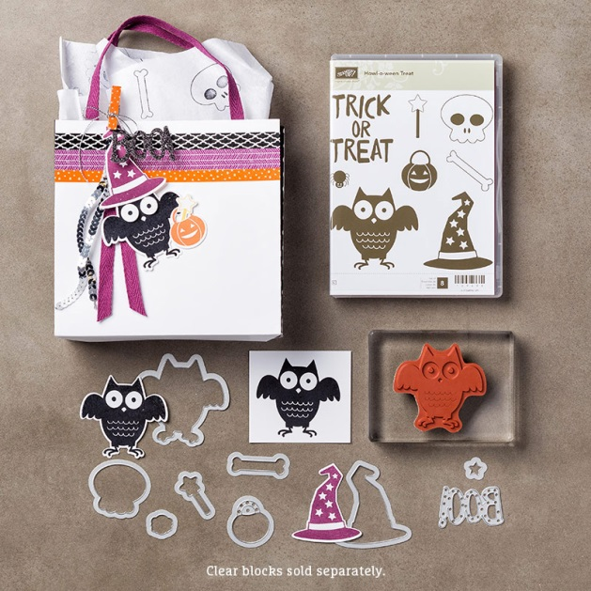

9. Peaceful Pines (p.17) What could be more versatile than a variety of trees. Use one or use a variety of styles to make your project festive. This is another great bundle saving 15%. Think about mixing this with another bundle like the Snow Place.
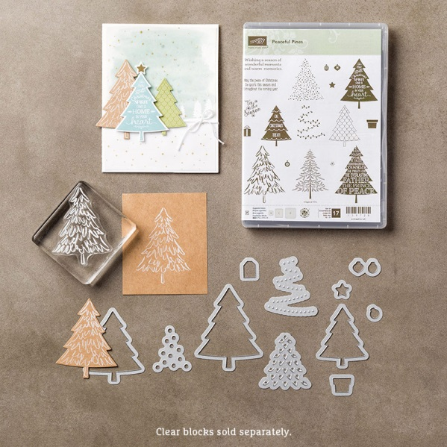

10. Versatile Christmas (p.26) Stampin’ Up! Is bringing you a stamp set that is perfect the inside and outside of your cards.
